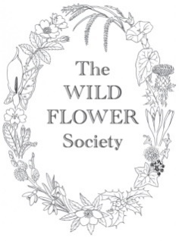
The Wild Flower Society Grant Application Form
Wildlife Trusts
Botanical Training for Volunteers

The Wild Flower Society invites you to apply for funding for both online and face-to- face training courses on identifying wild flowers and ferns for your volunteers. We offer grants of up to £250 per course. Trusts may apply for separate grants for online and face-to-face courses, and may also apply separately for children’s activities.
Please apply by sending this completed form to wfs.grants.fay@gmail.com before the beginning of March. Applications are considered at the WFS March committee meeting.
If you are applying for more than one grant, please fill in a separate form for each activity.
If you are successful in obtaining a grant, we ask that you acknowledge our support in your publicity and on your website or social media platforms.
A condition of the grant is that, once the training is completed, we require feedback in the form of a brief report of at least 200 words with photos, if possible.
Name of Wildlife Trust
Name of contact
Email of contact
Telephone of contact

Title of Proposed Training Activity and Location
Background Information for this project
How will be money be spent? Eg tutor fee, books, equipment
Who is the trainer, tutor eg a named experienced tutor
Number of volunteers
How many hours/days of courses are planned? Approximate Dates?
Type of habitat and associated plant species involved
How will this training benefit your organisation and your volunteers?

